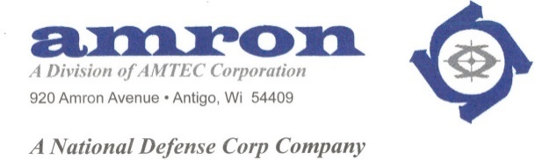

Amron, A Division of AMTEC Corporation

On-Site Interviews
On-Site Offers
All Positions

EVERYDAY (M – F) (7 a.m. – 3 p.m.)
September 1st, 2021 – December 31st, 2021
(Excluding All Holidays)

920 Amron Avenue
Antigo, WI 54409
(715) 623-4176

NO MANDATORY OVERTIME
NO MANDATORY WEEKENDS
GENEROUS BENEFIT PACKAGE
Including:
A significant 401k contribution to Each Employee
Advancement and Overtime Opportunities

EEO Employer/AA: Minorities, Women, Veterans, Disabilities

