JOB INTERVIEW 101

DOES THE IDEA OF GOING TO A JOB INTERVIEW MAKE YOU WANT TO RUN?

Come in and find out what to expect when going to a job interview. Everything from what to wear, what to bring, to what is appropriate to ask will be covered.

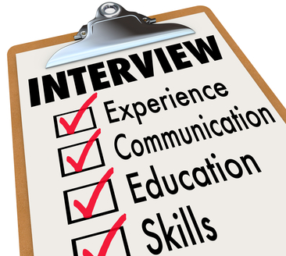
This Photo by Unknown Author is licensed under CC BY-NC-ND

Date: Monday, February 24th
Time: 1:00 p.m.
Where: Rhinelander FSET Office

