STRENGTH FINDERS

WANT TO BOOST UP YOUR RESUME?
Come to this two-part workshop series to discover your inner strengths and learn how to incorporate them into your resume!

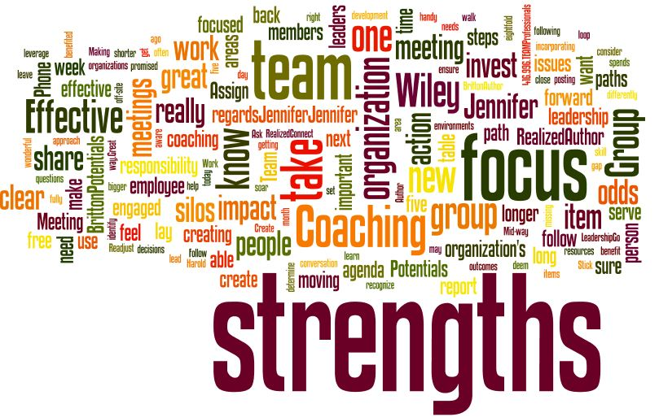
This Photo by Unknown Author is licensed under CC BY-NC-ND

Date: Monday, February 3rd and Monday, February 10th
Time: 1:00 p.m.
Where: Rhinelander FSET Office

